Our learning this half term
R.E
In R.E, we are studying the faith of Christianity. We are learning about the Creation Story and why it is still important to Christians today.
English
In English, we are studying the books Croc and Bird by Alexis Deacon, and Into the Forest by Anthony Browne.
We will be looking closely at exaggerated language and persuasion. We will be learning about the genres of fiction and writing a description.
Maths
We are learning about numbers to 1,000: adding, subtracting and representing the numbers in different ways.
We will be using a ruler and measuring in centimetres and millimetres.
Science
In Science, we are studying forces and magnets. We will be looking closely what materials are magnetic, where magnetism comes from and investigate the forces involved.
Music
In Music, our song this half term is called ‘Home Is Where The Heart Is’
and our focus will be on writing music down.
PSHE
In PSHE, we are learning about the Just Right Chart, looking closely at how we feel in each colour zone.
This will help us to get back to green, which is Just Right for learning. We will also cover the topic ‘Good to be me’.
History
We will be learning all about Ancient Greece, starting with a timeline so that we understand when exactly this civilisation existed in the past. We will then study education, and compare what children were taught in Sparta with what they were taught in Athens. We will also study some of the Great Thinkers from that period.

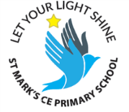
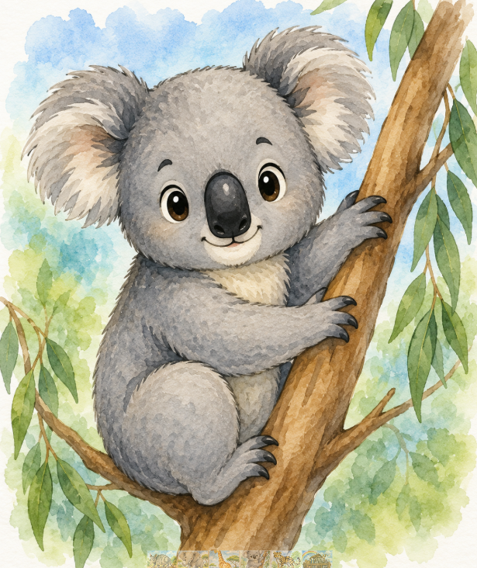
Koala Newsletter
Autumn Term 1

Dear Koala Families,
Welcome back to school for the fantastic start of your children’s wonderful learning journey in years 3 and 4. We have a wonderful new interior to our Koala Class, ready for our fresh start into our voyage of discovery! Discovering a love of reading and books is our big focus this year, which we are very excited about.
Uniform

All of our uniform can be purchased online from Sussex Uniforms.
https://www.sussexuniforms.co.uk/collections/st-marks-brighton

Our uniform is:
- Navy Sweatshirt or cardigan
- A white polo shirt
- Black or grey trousers, shorts or skirt
- Black school shoes

Your child should also bring a named book bag and a named water bottle.
Our PE day is on a Wednesday.
You need to keep a PE kit in school on your peg. You can wear black shorts or tracksuit bottoms, white t-shirt, trainers and school jumper. Please do not wear logos or coloured tops.
Thank you.
Reading Rock Stars!

Our book changing day is on a Friday.
Please aim to read for at least 10 minutes a day with your child. Encouraging them to read aloud builds confidence and speed. Each time your child reads, record it in their Reading Logs. If your child reads 5 times in a row, they are entered into our Reading Rock Stars Prize Draw!
If you have any questions please email:
admin@stmarks.brighton-hove.sch.uk
We try to check this every 48 hours.
Check out our website for lots of useful information
www.stmarks.brighton-hove.sch.uk

Homework and Spelling

There is a maths, spellings and grammar task weekly. Your child will use their login to access these tasks on the Purple Mash website:

www.purplemash.com

